Lab 8:
1. Write a program to determine point estimation and its bias for a sample of data with a given population mean.
Source Code:
#include <stdio.h>
int main() {
int n, i;
float sample[100], sum = 0.0, sample_mean, population_mean, bias;
printf("Enter number of sample data points: ");
scanf("%d", &n);
printf("Enter the sample data:\n");
for (i = 0; i < n; i++) {
printf("Sample[%d]: ", i + 1);
scanf("%f", &sample[i]);
sum += sample[i];
}
printf("Enter the population mean: ");
scanf("%f", &population_mean);
sample_mean = sum / n;
bias = sample_mean - population_mean;
printf("\n--- Results ---\n");
printf("Sample Mean (Point Estimation): %.2f\n", sample_mean);
printf("Bias: %.2f\n", bias);
return 0;
}
Output:
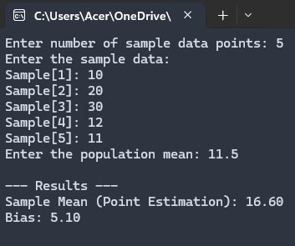

2. Write a program to determine interval/ confidence interval estimation for a sample of data with a given population mean.
Source Code:
#include <stdio.h>
#include <math.h>
int main() {
int n, i;
float sample[100], sum = 0.0, mean, population_mean, std_dev = 0.0, confidence_level, z, margin_of_error, lower_bound, upper_bound;
printf("Enter number of sample data points: ");
scanf("%d", &n);
printf("Enter the sample data:\n");
for (i = 0; i < n; i++) {
scanf("%f", &sample[i]);
sum += sample[i];
}
mean = sum / n;
for (i = 0; i < n; i++) {
std_dev += (sample[i] - mean) * (sample[i] - mean);
}
std_dev = sqrt(std_dev / (n - 1));
printf("Enter confidence level (e.g., 1.96 for 95%%): ");
scanf("%f", &z);
margin_of_error = z * (std_dev / sqrt(n));
lower_bound = mean - margin_of_error;
upper_bound = mean + margin_of_error;
printf("\n--- Results ---\n");
printf("Sample Mean: %.2f\n", mean);
printf("Confidence Interval: [%.2f, %.2f]\n", lower_bound, upper_bound);
return 0;
}
Output:
